Topic 2 - 1 – Defining functions piecewise
Big idea. Define a function in pieces when different equations are used for different intervals of the input

Example. This graph has three pieces. I could write out the equation for each piece along with the interval of x-values where it applies.
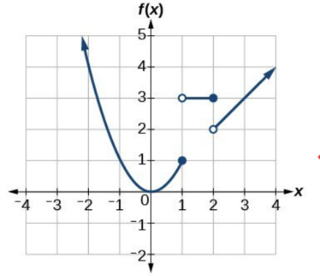
Use $f\left(x\right)=x^{2}$ when $x≤1$
Use $f\left(x\right)=3$ when $1<x≤2$
Use $f\left(x\right)=x$ when $2<x$

A piecewise defined function is just notation. It’s a different way to write all this information down at once. Here’s how it looks:
$$f\left(x\right)=\left\{\begin{matrix}x^{2} & if x≤1 \\ 3 & if 1<x≤2 \\ x & if 2<x\end{matrix}\right.$$

In general, you can think of it this way:
$$f\left(x\right)=\left\{\begin{aligned}equation 1 if x is in interval 1 \\ equation 2 if x is in interval 2 \\ equation 3 if x is in interval 3\end{aligned}\right.$$

Note that:
- Your function can have any number of pieces, not just 3.
- The pieces can’t overlap (then it wouldn’t be a function!)

Plugging in x-values to find outputs

What if I have $f\left(x\right)=\left\{\begin{matrix}\frac{1}{x}+1 & for x<2 \\ 2^{x-1} & for x≥2\end{matrix}\right.$ and I want to know $f(1)$, $f(2)$ and $f(3)$.
To find $f(1)$ you’ll want to plug $x=1$ into the equation. But which equation?
Look at the intervals where each equation applies. If $x=1$, that happens when $x<2$, which is the first interval. So you should plug $x=1$ into $\frac{1}{x}+1$ to get $f\left(1\right)=2$.
$f(2)$ matches the second interval when $x≥2$. So plug $x=2$ into $2^{x-1}$ to get $f\left(2\right)=2$
$f(3)$ also matches the second interval when $x≥2$. So plug $x=3$ into $2^{x-1}$ to get $f\left(3\right)=4$

When do you use piecewise defined functions?
Use them in situations when the overall behavior of something changes for different intervals of input.
Here are a few natural examples.
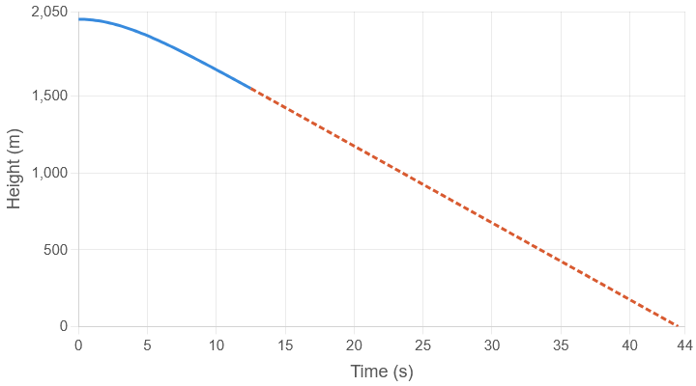
Free fall
A falling object accelerates down until the force of gravity matches the force of the air pushing back (called wind resistance or drag).
Here you see two pieces. The first piece is when the object is still accelerating down.
The second, linear piece, is when it’s reached terminal velocity and is falling at a constant speed.

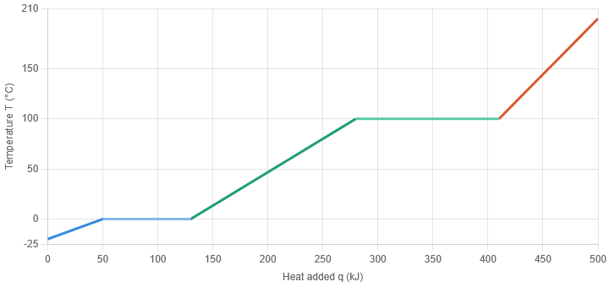
Phase changes for water
As you heat ice, its temperature increases until the ice begins to melt. As it melts, the temperature remains constant.
As you continue to add heat, the water gets hotter until it begins to boil away into gas. The temperature is again constant during the boiling phase.
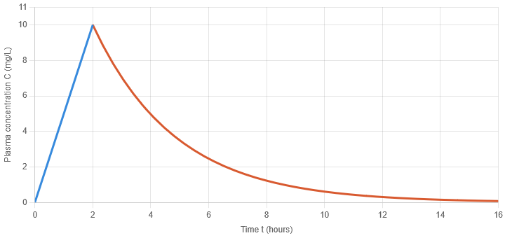
If you keep adding heat, the gas increases in temperature.
Pharmacokinetics (drug concentration)
An oral dose of a drug has to be absorbed into the bloodstream to be effective. In this absorption phase, the concentration in the bloodstream increases with time.
Eventually, the body’s clearance mechanisms dominate, and eliminate the drug from the bloodstream, causing the concentration to fall over time.
These equations are models of the real situations they represent. Models are almost always wrong. Reality is usually too complex to describe or predict perfectly. But the models are right enough to be useful. It’s common in science and engineering to use both more complex and less complex models of the same situation depending on what accuracy you need. We’ll come back to the drug concentration example and look at the different layers of simplification you can use to try and describe the complex reality.
Non-natural examples.
A big theme of this semester is that you can use equations to control things, instead of using them to try and predict or describe things.

[ tbc ]

